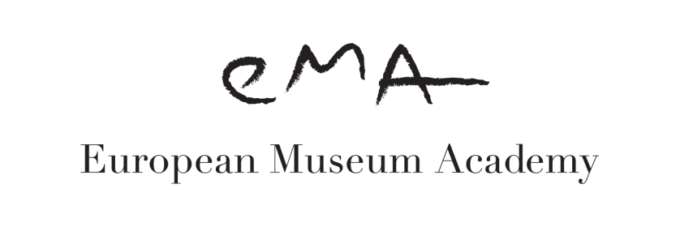
A EUROPEAN MUSEUM EXPERTISE FOUNDATION

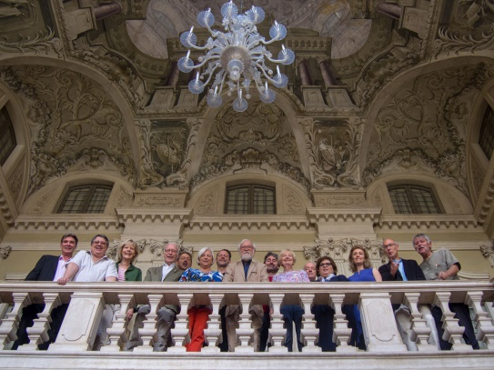

The 2018 EMA Annual Report

Agenda
January-December: Master Course in European Museology, International University of Media and Languages (IULM) Milan. This post-graduate course - in its 8th edition - is held under the auspices of the European Museum Academy. This cooperation has significantly grown this year: EMA has provided various experts for lessons as well as didactic materials.

A new Online Edition with a slightly different focus, under the title Master Course in Museology. New Media and Museum Communication, to enable students from all over the world to benefit from this programme, was launched in January 2017. All the modules of this course have been produced by EMA jointly with IULM. It is the only online course of its kind in the world.

May: International Summer School of Museology, Piran (Slovenia) - this course, now in its 12th edition, is co-organised with the Forum of Slavic Cultures (FSK), Ljubljana and the Primorska University. The general theme this year was WORDS In Museums.

10-11 June: Children in Museums Award Jury Meeting, at the Rijksmuseum, Amsterdam (The Netherlands).

22-23 June: 2020 EMA Task Force meeting and EMA Awards Jury Meeting, at the MUSIL Foundation in Brescia (Italy).

27-29 June: Meeting for pre-selection of the candidates of the Heritage in Motion competition.

30 August: Public event in Piran (Slovenia) co-organized by FSK/Piranova and the MUSIL Foundation to announce the winners of the Museums in Short contest. This scheme is organized under the auspices of EMA and a delegation attended the event.

September: Ziva Award Seminar and Ceremony (4th edition), Prague, at the National Museum of Technology. As in previous editions EMA supplied judges and expertise to the Forum of Slavic Cultures (FSK), the creator of the scheme.

20–22 September: EMA Annual Meeting and EMA Awards Ceremony at Den Gamle By in Aarhus (Denmark) During the meeting the Heritage in Motion Awards Ceremony was held at the same premises in co-operation with Europeana and Europa Nostra. During the meeting a special Seminar was held with PASCAL network, entitled “Cultural Policy and Literacy development”

22-23 October: EMA co-organized with TIM the Textile Museum of Augsburg and the Bayerische Academy a two-day event on “The Art of Attraction”.

17 November: The Children in Museums Award Ceremony in Valletta, Malta took place during the NEMO Conference.

31 November-1 December: The 2018 Kenneth Hudson Seminar was held in the Italian town of Forlì which is the coordinator of the ATRIUM European Network. The theme was how to develop new approaches to preservation and interpretation of the architectural Dissonant Heritage of the XX century.
7-8 December: EMA Director attended the Annual Russian Congress of City Museums at the City Museum of Moscow.

Strategic Partnerships
Following our strategy to enlarge the network of institutions regularly working with us on specific long-term projects, following actions should be noted:

A substantial implementation of the existing cooperation with NEMO: the editing and the research work of the 2018 NEMO publication on European award schemes. Participation in the Berlin event at the Museum of Communication held in July in the context of the 2018 EYCH.
A similar line has been followed with FSK with which several projects are under study for the next two years.
Hands On! International Association of Children in Museums: EMA signed a Cooperation Agreement, 5 out of the 10 jurors are provided by EMA.
Not to be underestimated is our active membership of the European Heritage Alliance, an informal European platform composed of 40 European or international networks and organizations active in the wider field of cultural heritage. Our presence in this initiative from the very beginning has been increasingly proactive.

The important Agreement of Cooperation signed in 2017 with PASCAL, the international alliance on regional development, social cohesion and lifelong learning.

Board Meetings and related issues.
The EMA Board met twice: in The Hague and in Aarhus, September 22.
From January 1 2019 Wim van der Weiden will be succeeded as Chairman by Karl Murr
Massimo Negri will become Scientific Director and Henrik Zipsane, Managing Director.
Finances
The financial situation is stable, thanks to the continuing support of the growing number of Associate Partners.

The number of candidates for the 2018 European Museum Academy Awards (Micheletti Award and DASA Award) has risen to 29 from 18 countries. Candidates for the other awards connected to EMA have also increased.
EMA Annual Event : Venue
The 2019 EMA Conference and Award Ceremony will be held in Ljubljana (Slovenia) from 19 to 21 September thanks to the hospitality of the Forum of Slavic Cultures (FSK) . The event will celebrate the 10th anniversary of EMA . FSK is also celebrating its 15th anniversary.

EMA IN SHORT

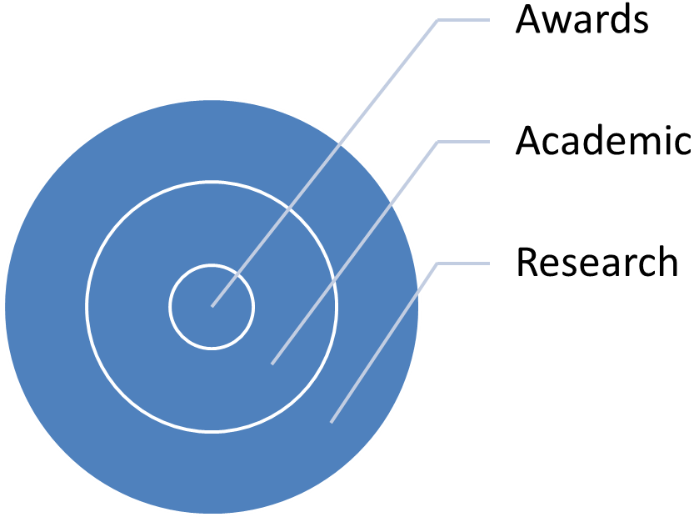

These prevalent points of interest have been confirmed by the EMA Board as the lines which fulfil the EMA Mission and the guidelines for the coming years’ plans.
In order to foster our vision and develop new projects, the 2020 EMA Task Force established with René Capovin, Karl Borromäus Murr and Elia Vlachou, has been implemented with Dirk Houtgraaf and Henrik Zipsane as members of the team. The Task Force has produced a document which has determined important decisions by the Board. Among the other things it has been agreed that in 2019 Massimo Negri will move the newly established position of Scientific Director and Henrik Zipsane will play the role of Managing Director.

EMA ORGANISATION
This aspect has been widely discussed and in 2019 relevant changes are expected.
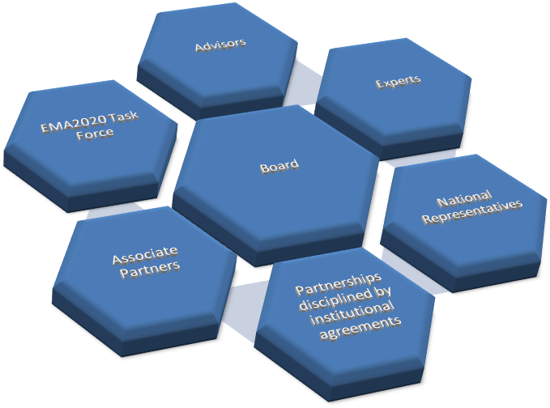

STAFF
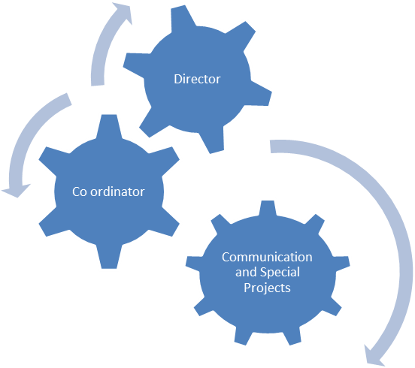

The European Museum Academy Awards
The Micheletti Award and the DASA Award
The EMA Prize

Award Schemes where EMA is playing a strategic role as a permanent partner.

Children in Museums Award
On Saturday 17 November at the NEMO Conference in Valetta, Malta, the results of the 2018 Children in Museums Award were announced. 35 museums took part in the competition this year, with a short-list of 12 finalists. The entries were of an extremely high quality and a real testament to the growing maturity of a relatively new field for the museum profession. The judges were unanimous in their decision to make the Keppel Centre for Art Education at the National Gallery Singapore the winner of the 2018 Children in Museums Award.

Heritage in Motion
The results of the fourth edition of the Heritage in Motion competition were announced during the European Museum Academy Awards meeting in Aarhus, Denmark. The Award celebrates innovation of digital technologies, (social) media and film/video in the field of cultural heritage and is the result of a co-operation between Europa Nostra, Europeana and EMA.

Museums in Short
The 5th edition of this Award Ceremony , which aims to enhance public awareness of the role of museums in innovative video production, took place on 30 August in a beautiful square of the town of Piran thanks to the co-operation of the Forum of Slavic Cultures. There were categories for short films and short presentations, and an opportunity for a public special mention, with an online voting platform which attracted more than 1,000 voters. The Award is a co-operation between EMA, the Fondazione Brescia Musei, MUSIL Foundation – Museum of Industry and Labour, in collaboration with ICOM International and ICOM Italy.

The Ziva Award
The Ziva Award, promoted by the Forum of Slavic Cultures with the assistance of EMA, organised its Seminar and Ceremony in Prague, the Czech Republic in September 2018.

ACADEMIC ACTIVITIES
In addition to the Master Courses in Milan and the Summer School in Piran a closer cooperation with the Erasmus Mundus Programme of Study on Industrial Heritage “TPTI” has been formulated. This is run jointly by La Sorbonne in Paris, the State University of Padua and the University of Evora. At the State University of Padua it maintained and made accessible to students and professors the Kenneth Hudson Library of books on industrial heritage.

RESEARCH
The work for a research project on the theme ‘The Museum of the Future – Between Physical Place and Virtual Space’ is continuing under the co-ordination of Karl Borromäus Murr. This project will give rise to the publication of a book, hopefully in a year’s time.

A project for the reorganisation of the EMA digital photographic archive is at present under consideration, in cooperation with the University of the Aegean in Crete. It is hoped that some concrete results will available in 2020.

EMA ASSOCIATE PARTNERS
We are happy to welcome new Partners in 2018:
Gallery 11/07/95, Sarajevo, Bosnia and Herzegovina
Muzeul Bocuvinei, Suceava, Romania

CORPORATE PARTNER
Bursa Metropolitan Municipality, Bursa, Turkey

ASSOCIATE PARTNERS
Gallery 11/07/95, Sarajevo, Bosnia and Herzegovina
TIM, Staatliches Textil- und Industriemuseum, Augsburg, Germany
IULM Communication Mgt SCARL, Milan, Italy
Natura Artis Magistra, Amsterdam, The Netherlands
National Museum of the Romanian Peasant, Bucharest, Romania
Muzeul Bocuvinei, Suceava, Romania
Fundación Caixa d’Estalvis i Pensions de Barcelona, Spain
Museu Agbar de les Aigües, Cornellà de Llobregat, Spain
Association of Swedish Museums, Karlskrona, Sweden
Istanbul Toy Museum, Istanbul, Turkey
Glasgow Life, Glasgow, UK
Event Communications, London, UK
The Nordic Centre of Heritage Learning & Creativity, Sweden

INDIVIDUAL PARTNERS
Hartmut Pöll, Alpinarium, Galtür, Austria
Riitta Nelimarkka-Seeck, Helsinki, Finland

Massimo Negri
EMA Scientific Director
February 2019

